CAYUSE APPROVALS FOR SPONSORED PROJECTS
Faculty who pursue funding opportunities from external sponsors (sponsored projects) must obtain internal approvals from appropriate university administrators prior to submitting an application. As authorized submitters, the Office of Grants and Contracts initiates this process. As Department Chair, you will be required to approve projects within the CAYUSE system for faculty within your department who are in the process of submitting an external application for funding.
Ideally, faculty should notify their Department Chair of their intent to apply to an external funding opportunity and discuss what they will be using the award for (course release, summer pay, hiring a student, supplies, travel, etc.), and what resources they may need.
The internal approval process is to notify those on the routing chain:
- that a proposal is being submitted;
- how much funding the faculty is requesting;
- what the faculty intends to do with those funds;
- what to expect should the project be funded
By providing an “approval” in CAYUSE, the appropriate administrator confirms notification of an upcoming proposal submission, and indicates they have had the opportunity to review the proposed activities and resources requested for the proposed project.

KEY INFO
What is CAYUSE?
CAYUSE is a web application created to simplify the creation, review, and electronic submission of grant proposals. The system performs error-checking based on the agency, funding opportunity guidelines, and system validations.
CSUF also uses CAYUSE for internal approvals from appropriate university administrators before an application is submitted to the sponsor or funding agency. These approvals are a pre-submission requirement. CAYUSE is used to route approvals approximately seven (7) business days before the sponsor deadline. There may be exceptions to this timeline, and you may be requested to submit an email approval if needed.

WHO ARE THE OTHER APPROVERS?
Generally, the following administrators provide approvals via CAYUSE:
- Director, Office of Sponsored Program
- AVP for Financial Services & Administrative Systems/Controller
- PI and co-PI (if applicable)
- Department Chair (that’s you!)
- Academic Dean
- AVP of the Office of Research and Sponsored Projects
Depending on the project, additional individuals may be added to the approval chain, such as the AVP of University Advancement Operations, AVP of Facilities Planning and Management, Risk Management, Research Compliance, etc.

What documents should the Chair review?
The following four (4) documents are required for routing and approvals; of these documents, please prioritize reviewing those highlighted in YELLOW.
- Proposal/Project Narrative (draft)
Since routing begins seven (7) business days prior to the sponsor deadline, faculty are still finalizing their proposal. A draft of the proposal or a project summary is typically used for internal routing purposes. It is helpful for you to review this document first because it will give you an overall idea of what the project is and what the faculty intends to do. It is not the Department Chair’s responsibility to edit or provide feedback on the proposal as part of the internal approval process.
Only final versions of required application documents will be submitted to the sponsor.
- Internal Budget Narrative/Budget Justification (final)
The internal budget narrative or budget justification explains project details by laying out who will accomplish what and when, and how those costs are calculated. This document will also detail if faculty are asking for course releases, summer pay, overload; if and how many students will be hired; if and how much equipment or supplies are budgeted; and if cost-match or cost-sharing is being requested.
- Internal Budget (final)
The internal budget is an Excel workbook used by the Office of Grants and Contracts to create a budget for the proposal. If awarded, post-award units will use this document to create project expense accounts, determine time and effort reporting, tracking expenditures, etc.
- Internal Routing Form
Although the Internal Routing Form is required to initiate routing, the Office of Grants and Contracts uses the form to create the project in CAYUSE and transfers information from the form into the Project Summary and other parts of the proposal. This form will not appear in the approval documents section.
How does the Chair know if a project needs CAYUSE approval?
They will receive an automated e-mail message with a link to the proposal.

INSTRUCTIONS FOR REVIEWING DOCUMENTS AND PROVIDING APPROVAL IN CAYUSE
Appropriate administrators included in the internal routing chain will receive an automated e-mail message with a link to the proposal in CAYUSE. Click on the link in the email to review proposal documents and follow the steps below to review and approve:
1. Login to CAYUSE using your CSUF single-point login information; this will require DUO authentication.
2. To view proposal documents, navigate to the menu bar on the left-hand side of the screen to the Proposal Summary heading, and click on “Supporting Documents.” This will take you to a page where you can open and review the attached proposal documents.

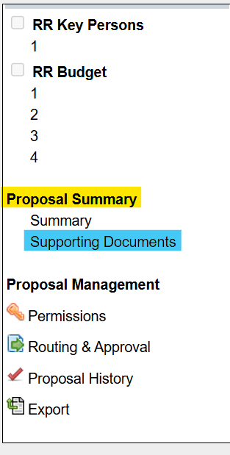

3. To give approval, navigate to the menu bar on the left-hand side of the screen, to the Proposal Management heading, and click on “Routing & Approval.”

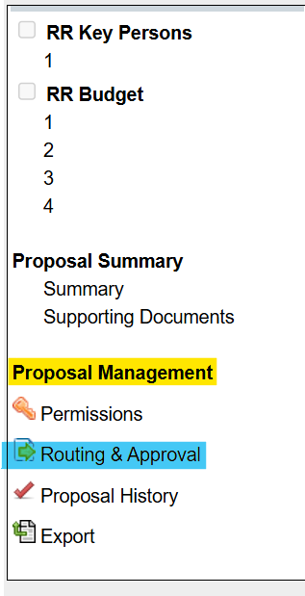

4. Select and click on the square next to your name and follow the prompts to complete your approval.
5. Once completed and you will see a “check” next to your name.
6. Last step (very important) - be sure to back out of the system by clicking on the “Double Green Carrots” in the blue bar at the top. It will look like this:


